# How to connect to Chype Database Using Robo 3T?

## Wait ReadMe before you proceed:

1. You need Robo 3T (UI) or Mongo Shell
2. This document describes the way to connect to MongoDb in atlas could using Robo3T
3. Link to Download Robo3 T and setting up detials as below

## DownLoad and Install:

1. Link <https://robomongo.org/download> and click download Robo3T

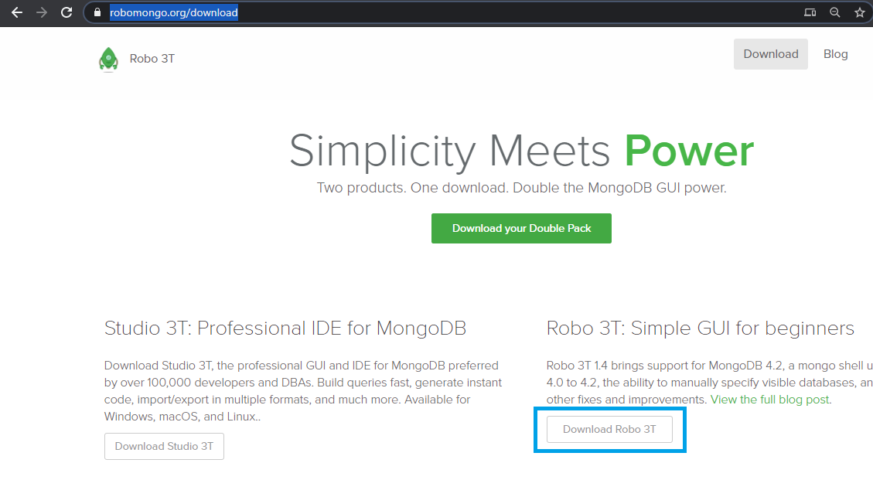

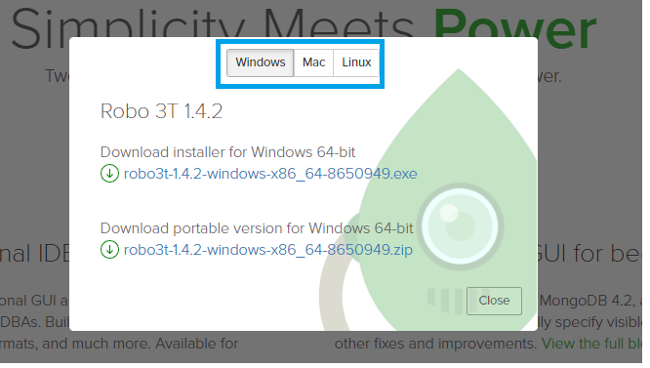

## Setting Connection in Robo3T

1. Once you have downloaded and Installed Robo3T, Open the application using your start menu(windows) or LaunchPad(mac) here is windows example

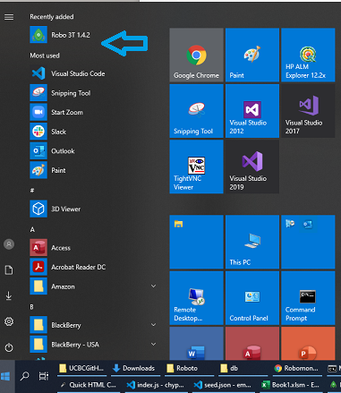

1. You should see Robo3T window as below

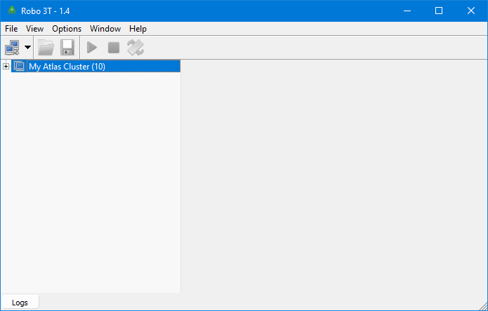

1. From Here Click on Manage Connections menu on top left

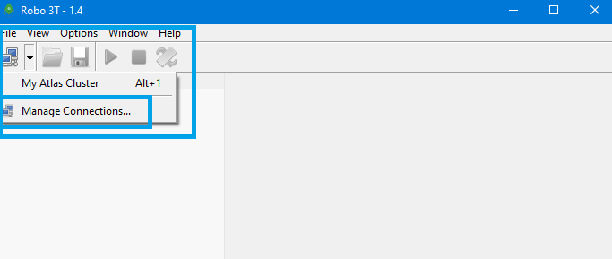

1. The create connection window should pop up

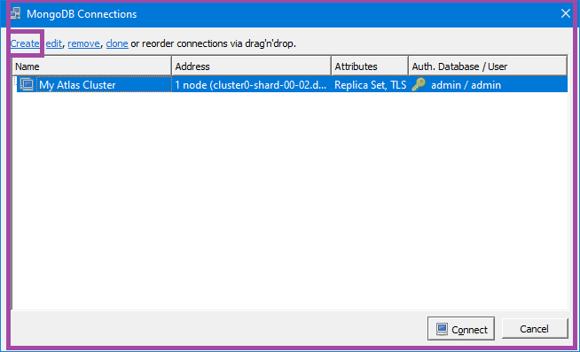

1. Hit Create Link
2. Now in the Connection settings window you need to use the following connection string so…
3. Be sure to replace the <username> , <password> and <dbname> placeholders with your names and password – The dbname, username and password will be provided to you in the slack ☺ security reasons!
4. mongodb+srv://<username>:<password>@cluster0.l7vvi.mongodb.net/<dbname>?retryWrites=true&w=majority
5. see example snapshot below

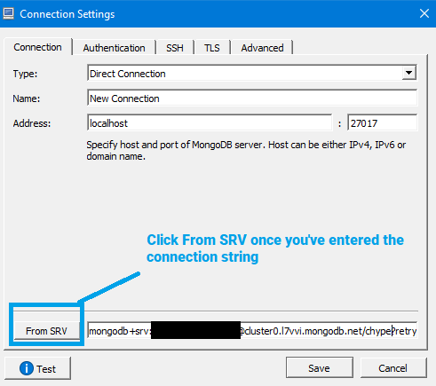

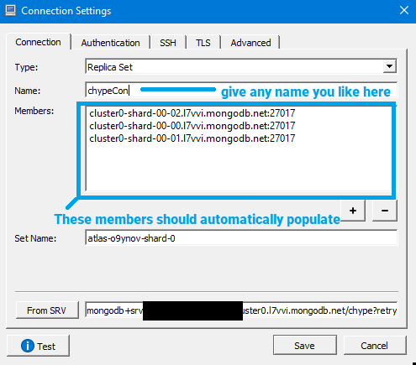

1. Now on the **authentication** tab

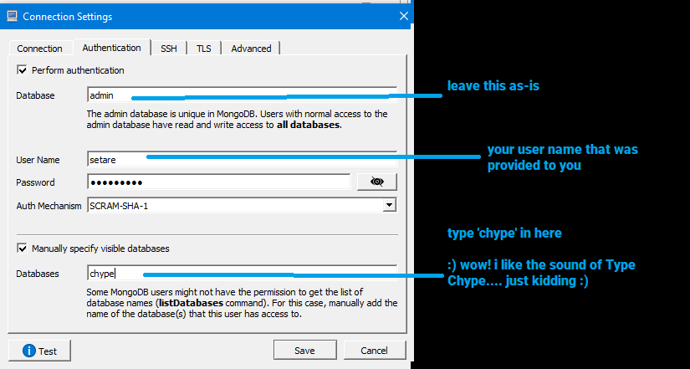

1. Hit Test button

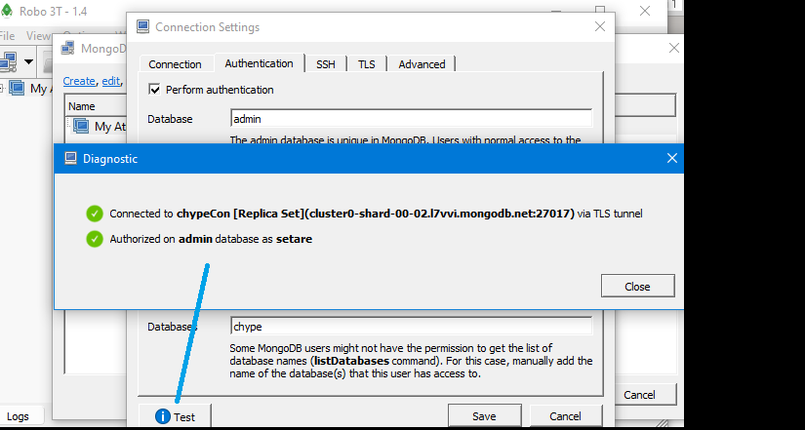

1. Close and save!
2. Now you should be back to the main connection window

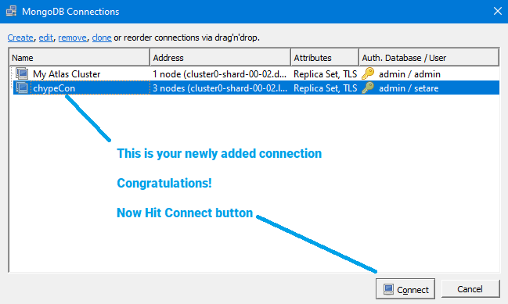

1. In the main Robo3 T window you should now see the Chype database with single collection ‘users’

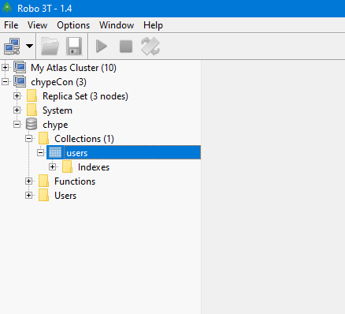

1. That’s it for now!